**Setting Up a DHT22 Temperature and Humidity Sensor to collect Data**

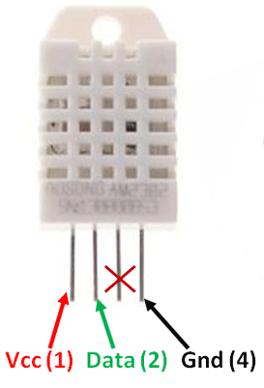

Reference Video: [**https://www.youtube.com/watch?v=EcyuKni3ZTo&t=116s**](https://www.youtube.com/watch?v=EcyuKni3ZTo&t=116s)

Install the adafruit DHT22 library. On the terminal run..

sudo pip3 install adafruit-circuitpython-dht

**if you encounter error during installation, do this**

sudo apt-get update

sudo apt-get upgrade

sudo pip3 install --upgrade adafruit-blinka adafruit-circuitpython-dht

sudo pip3 install adafruit-circuitpython-dht

**Wiring Diagram DHT 22 AND LDR**

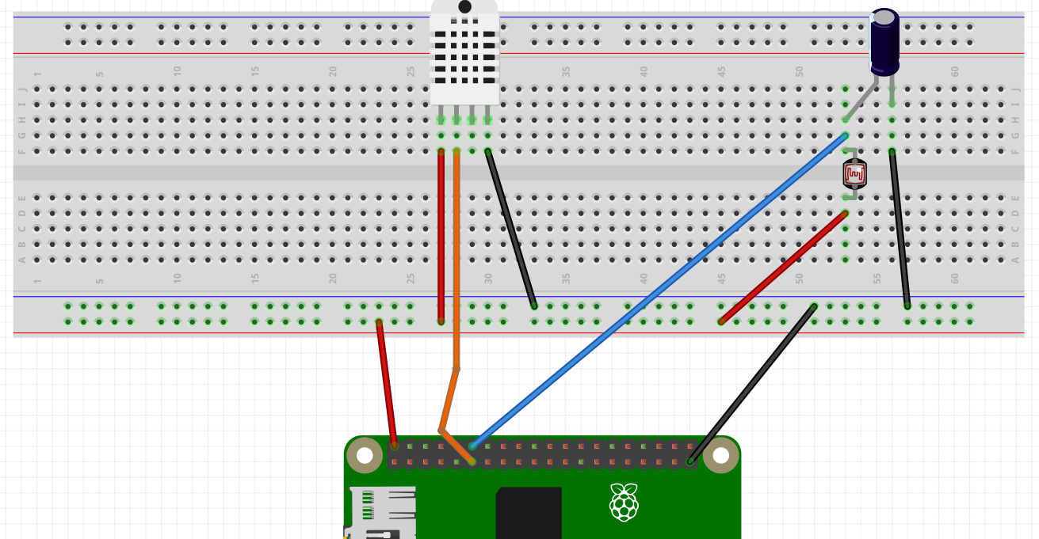

**LDR**

**+ve**

**10 uF Capacitor**

**V D X G**

**PIN 18**

**PIN 17**

**Demo: dht22adafruit.py**

Other types of Temperature and Humidity Sensors, using different kinds of libraries can be used with the Raspberry Pi to.

The BME280 is another popular Temp/Humidity sensor.

Here is a video for the BME280.

<https://www.youtube.com/watch?v=ChQpD2gsC20>